**Tableau join and union:**

The difference ways in how the data is combined. In simple terms, joins combine data into new columns. If two tables are joined together, then the data from the first table is shown in one set of column alongside the second table's column in the same row. Unions combine data into new rows.

**Join :**

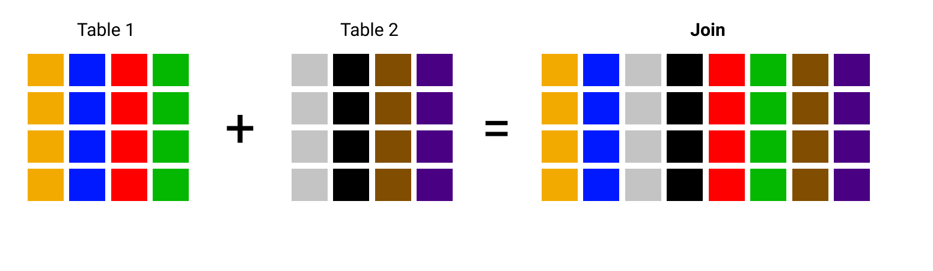

**Union :**

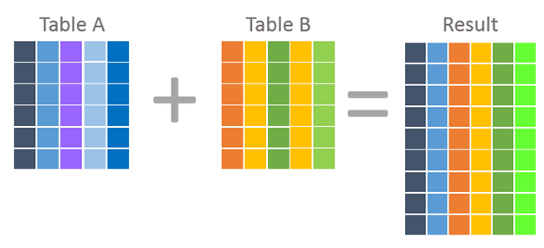

**Tableau sort**

Tableau sorting means here we can swap row and columns (ctrl+w).

Also we will perform ascending (lower to higher ).

we will perform descending ( higher to lower )



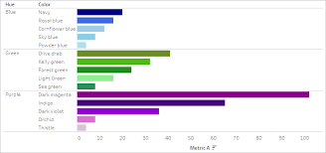

**Tableau forecasting:**

**Used in business intelligent to make prediction for investments or different purposes.**

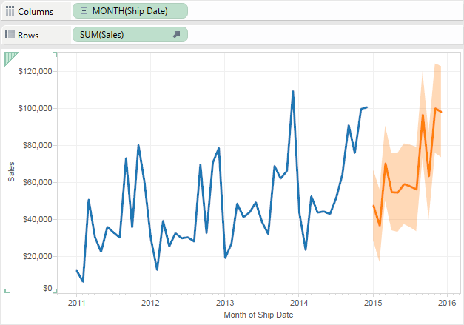

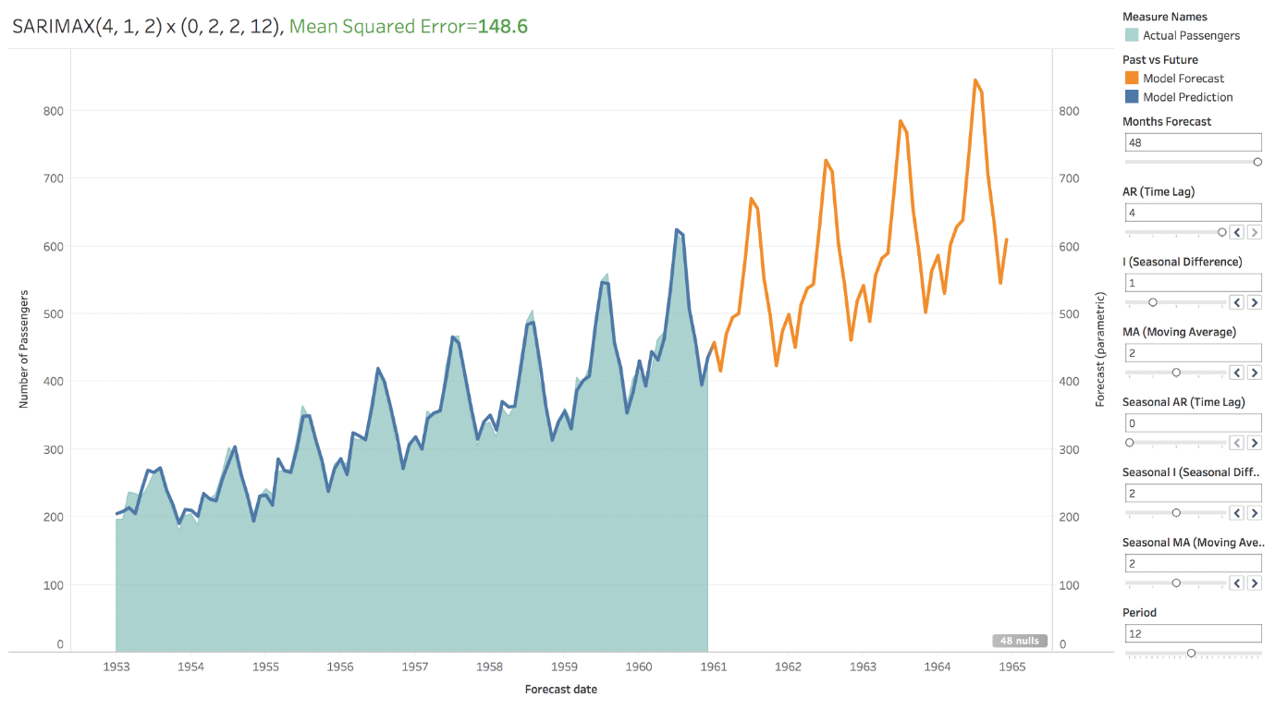

**Tableau highlight**

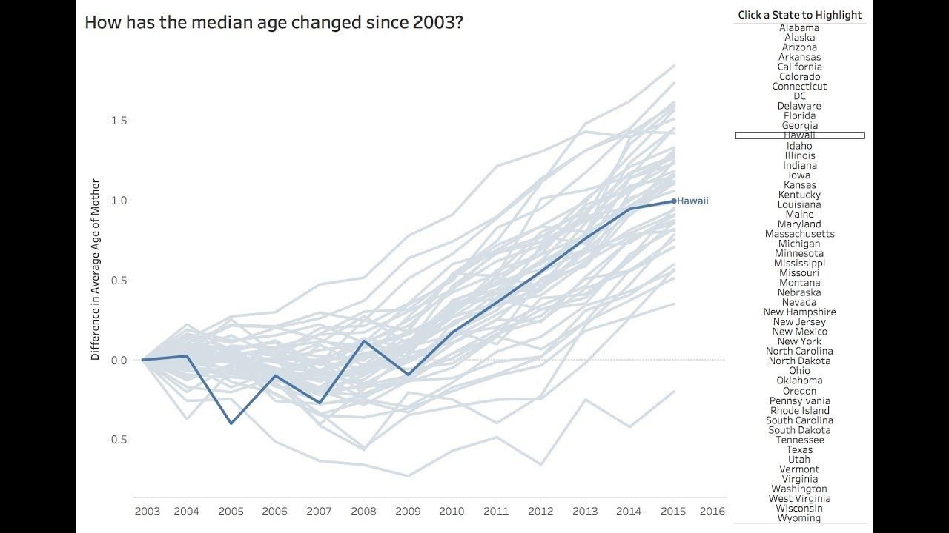

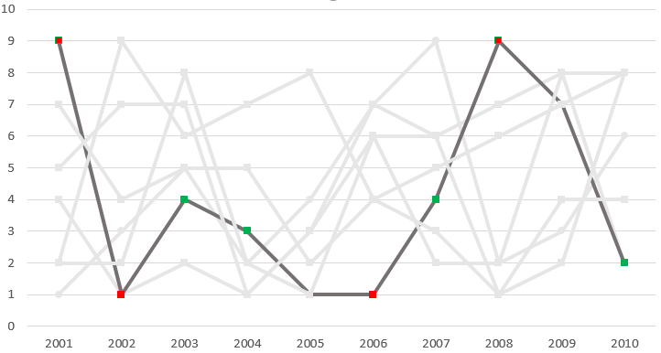

**Tableau trade line**

The Trend lines in Tableau are **used to estimate the trend of the variables**. It helps to identify the relation between the two variables by observing the trend of the variables simultaneously.

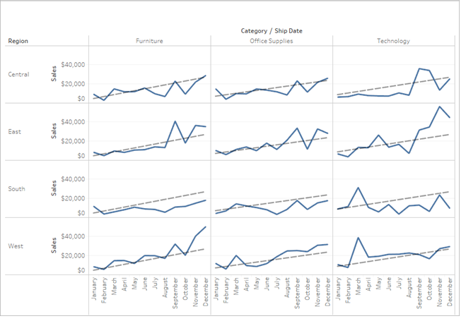

**Tableau blending**

Data blending is **a method for combining data from multiple sources**. Data blending brings in additional information from a secondary data source and displays it with data from the primary data source directly in the view.

1. **What is primary data? – blue tick**
2. **What is secondary data? – red tick**

